Computer Network lab
Date: 27-08-26
Host Commands

- C:/hostname
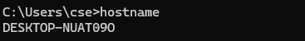

- D:/ipconfig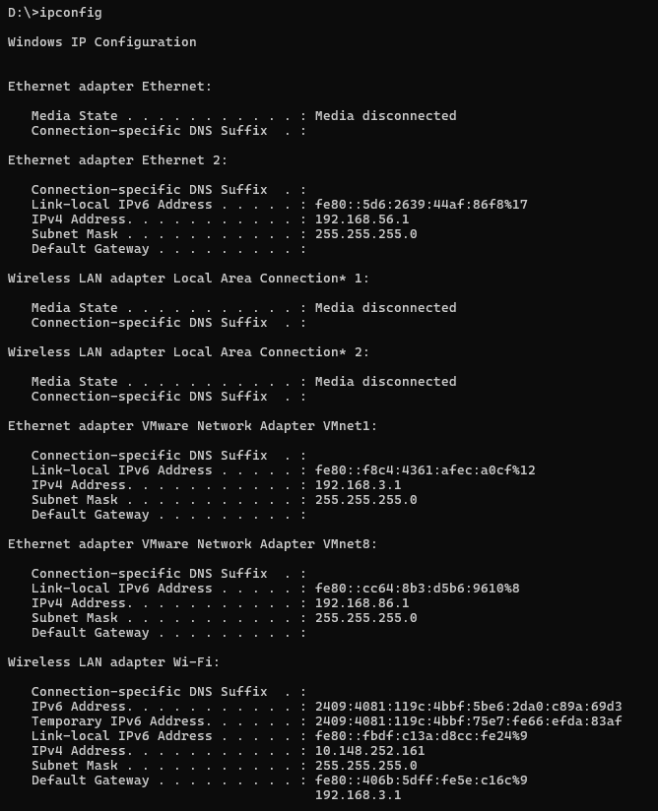

- D:\>getmac
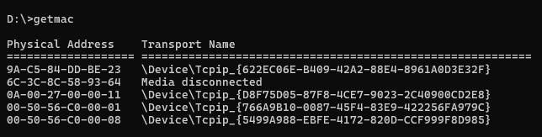

- D:\>ping rbunagpur.in
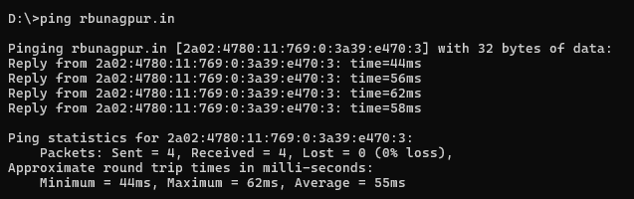

- D:/>nslookup google.com
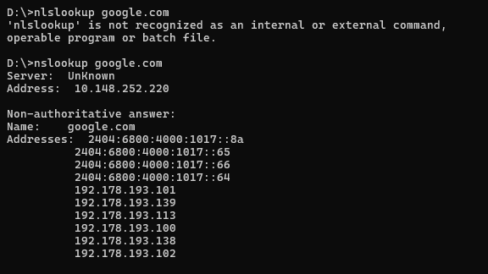

- D:\>nslookup 8.8.8.8
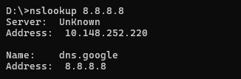

- D:\>ipconfig /displaydns
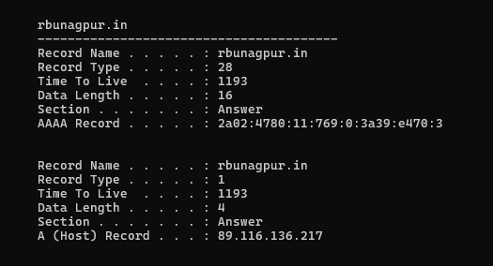

- D:\>ipconfig /flushdns
